Real-Time Bridge Monitoring

Requirements Specification

Version 1.4

Revision History

Date | Version | Description | Author
2013-11-06 | 1.0 | Initial Version | Nikola Radisavljevic  Miraldi Fifo  Dzana Kujan
2013-11-07 | 1.1 | Changed the structure of requirements definitions and edited text for requirements  Improved the text  Captions for illustrations added | Dzana Kujan
2013-11-07 | 1.2 | Section 3 – changed requirements definition from must to should  Section 3.1. - added abbreviations for all requirements  Updated Appendix | Dzana Kujan
2013-12-04 | 1.3 | 1.1. User characteristics updated  2.3.1 Administrator functions updated  2.3.2 Human Controller functions updated  2.3.3 Engineer functons updated  2.3.4 External User functions updated  Use cases updated:  2.4.5 Historical Status  2.4.7. Change Debris Value  2.4.9 Deleted  2.4.10 Deleted  2.4.10 Added – change traffic value  2.4.11 View Users  2.4.13 View M-N domain  2.4.15 Change history range  2.5 Constraints text updated  2.6 Assumptions text updated  Illustration 2. Administrator functionalities updated  Illustration 3. Human Controller functionalities updated  Illustration 4 changed  Illustration 5 deleted  Following requirements updated:  3.1.1 External User functionlities  3.1.2 Human Controller functionlities  3.1.3 Engineer functionlities  3.1.4 Administrator functionlities  3.1.6 Calculations  3.1.7 External Interfaces  4. Appendix updated with new parameters | Dzana Kujan  Nikola Radisavljevic
2014-01-06 | 1.4 | Text Format and minimal fixes | Andrea Bottoli

Table Of Contents
1.Introduction 4
1.1Purpose of this document 4
1.2Scope 4
1.3Definitions and acronyms 4
1.4References 6
2.Description of the system 7
2.1Background 7
2.2User Characteristics 7
2.3Product functions 8
2.4Use Cases 10
2.5Constraints 13
2.6Assumptions 14
3.Requirements Description 15
3.1Functional requirements 16
3.2Non-Functional requirements 25
3.3Requirements for the future 25
4.Appendix 26

Introduction

Purpose of this document
The purpose of this document is to state all gathered requirements and to explain system in more details. This document will be used to proof that development team and customer have the same view of what the system is supposed to do and how. The document will also be helpful to the developing team in the design and implementation phase in order to implement the desired functional and non-functional requirements. The requirements that are specified in this document are written in a way that makes them testable, so they will be further used in the testing phase to ensure that all the requirements have been met. Finally, the document will also be object of supervision from the supervisor of the project.

Scope
The document is split into five major parts: Description of the system, Requirements description, Requirements definition, Future development and Appendix.
In the part “Description of the system”, at the beginning brief recall of the background of the existing system is given. After that the functions of each actor from use case diagram is explained. The constraints and assumptions are also covered in this part.
The second part of this document is “Requirement description”. All requirements, regarding Sensor data presentation, engineer functionality, administrator functionality, external user functionality and calculations are described in details in this section. Also, future development requirements are stated in this section, although they will not be considered in the further development phases of this project, for now.
The purpose of the third section, “Requirement definition”, is to give a priority to each requirement described in Requirement description section. This is done by putting all the requirements in a table along with their priorities.
At the end, table of parameters used in document is given, this way it is easier to understand the document and meaning of the requirements.

Definitions and acronyms

Definitions

Keyword | Definitions
Labview Encode | Number of seconds that have elapsed since 1st January 1904, on the Greenwich meridian
Debris | Obstacle stuck on the pillar 30 of the bridge

Acronyms and Abbreviations

Acronym or  abbreviation | Definitions
ANE1 | Mean wind speed in 10 minutes
ANE2 | Maximum wind speed in 10 minutes
ANE3 | Mean wind direction in 10 minutes
ANE4 | Direction of the maximum wind speed in 10 minutes
IDRO1 | Mean water depth/water height in 10 minutes
IDRO2 | Variance of the sample in 10 minutes
Data of type ① | Parsed sonar height value, with format Rxx.xx
Data of type ② | Parsed sonar height value, with format Rxx.xxE
Data of type ③ | Parsed sonar height value, with format xx.xx
Data of type ④ | Parsed sonar height value, with format R99.99E
Data of type ⑤ | Parsed sonar height value, E1 or missing data
SONAR1 | Mean value of the height of the bottom (only with data of type ① and ②), in 10 minutes
SONAR2 | Variance of the sample (only with data of type ① and ②)
SONAR3 | Percentage of data of type “① + ②” used compared to the 600 elements of the sample data, in 10 minutes
SONAR4 | Percentage of data of type “③” there are in the sample data, in 10 minutes
SONAR5 | Percentage of data of type “④” there are in the sample data, in 10 minutes
SONAR6 | Percentage of data of type “⑤” there are in the sample data, in 10 minutes
SONAR7 | Percentage of data of type “②” there are, considering as sample the “① + ②” set of data (so not all the 600 data), in 10 minutes
 | The push of the wind on the planking
 | The push of wind on the traffic.
 | Effective value of the wind speed
 | Drag planking
 | Air density
 | Planking area
 | Traffic combination A1
 | Traffic combination A2
 | Traffic combination A3
hwater | IDRO1
Q | Flow rate value
Vwater | Relative value of water speed
hMAXwater | Maximum water height. If hwater > hMAXwater , the river has overflowed.
 | Portion of palking

References
It is necessary to read through the following documentation in order to fully understand the system that is being developed.
[1] Project plan and description document of the project Real-Time Bridge Monitoring
[2] Real-Time Assessment of Bridge Vulnerability, Gianluca C., Francesco B. et al.
[3] Sistema di monitoraggio di Borgoforte, Francesco B., Alfredo C, Gianluca C. et al.

Description of the system

Background
The bridge we are monitoring, named “Borgoforte”, is situated on the Po river. On the bridge some of the piles are enforced but there is one pile which is week and needs to be monitored. On this pile there is a number of sensors measuring physical force that different sources make on bridge. Moreover, two cameras are providing pictures from both sides of the bridge. All data from sensors and pictures from cameras are stored in files and sent to the server in packages each hour.
Our goal is to make a system for storing, calculating and presenting all relevant data of the bridge. We have to extract data from .txt files and store them to a database. After that calculations have to be done according to a large number of parameters which all influence the bridge status. The calculated level of danger of the bridge is also stored in the database. Finally, both current and history data along with pictures can be presented to the user.

User Characteristics
Four types of actors have been identified: the Administrator, the Human Controller, the Engineer and the External User. The way of interacting with the system depends on the type of the user. The users are presented in the following illustration.
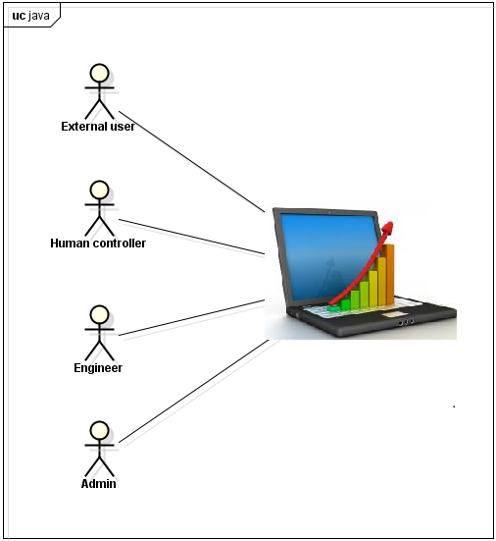Illustration 1: Users of the system
The Administrator manages the users accounts, the human controller monitors the bridge current state and history, the Engineer is the one who has all knowledge about equations and is allowed to change the parameters, and the external user doesn't need to have any knowledge of the system since he is only allowed to see reduced set of current state of the bridge.

Product functions

Administrator Functions
The Administrator can only manage the users and does not have authorization to change any system parameters. He can view all users, register a new user, edit users, delete a current user and log out. The administrator does not need to have knowledge about the calculations or how the system works at all.
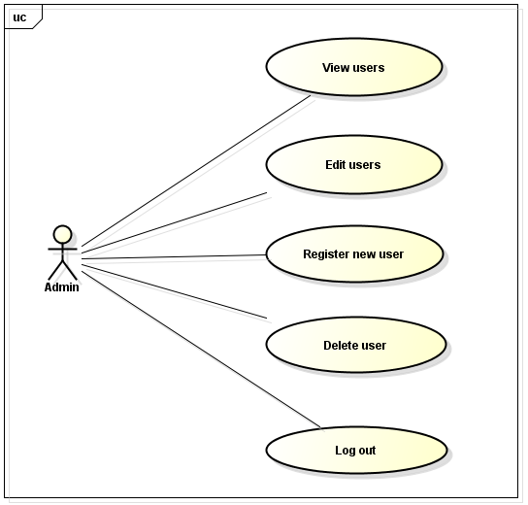Illustration 2: Administrator functionalities

Human Controller Functions
The purpose of the Human Controller is only to monitor the condition of the bridge view the historical data of the bridge. The human control can see the current status of the bridge and the historical status of the bridge. In the current state, the M-N domain is presented, with a graphical representation of each pylon and its position in this domain. This information includes also the safety factor and alarm state. The safety factor is a product of the calculations. The alarm state represents the level of current danger of bridge to collapse. It can be on or off. If the alarm is on, the human controller can decide if he wants to send an email to a person responsible for the danger state of the bridge. The Human Controller can log out and then interacts with the system as an external user.

Engineer Functions
The Engineer has the same functions as the Human Controller and an additional one. The Engineer can change all variable parameters that are taken into account while performing the calculations. Moreover, engineer can also log out and then interacts with the system as an external user.
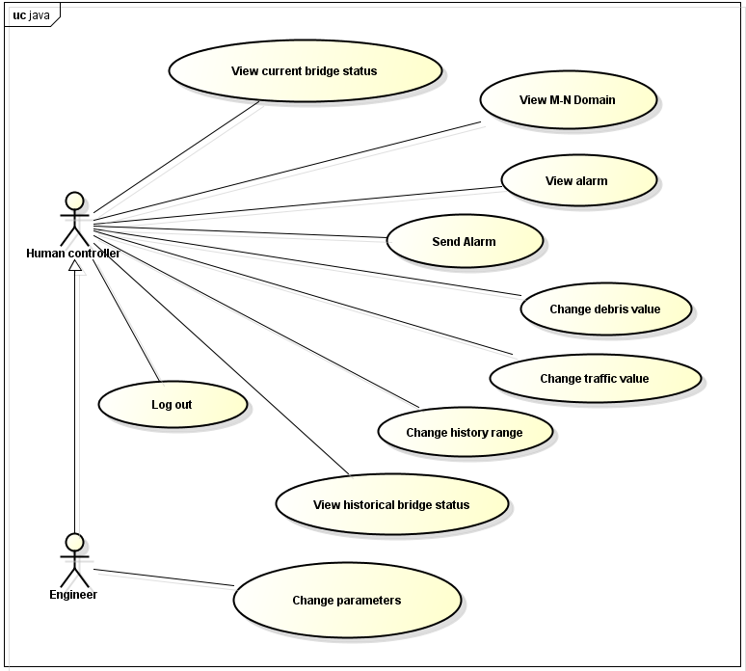Illustration 3: Human Controller and Engineer functionalities

External User Functions
The External User doesn't need to have any knowledge of the calculations and historical data, since he is just a guest. The External User can see just basic information of the Bridge. This information is current status of the bridge. He can log in and then interacts with the system as a registered user.
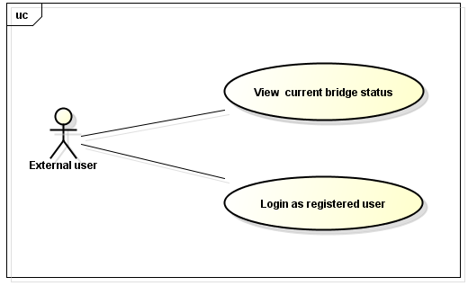Illustration 4: External User functionalities

Use Cases

Register New User
Goal: To add a new registered user
Participating Actors: Administrator
Related Use Cases: none
Precondition: The user must be logged in as an administrator
Main flow of events:
  - The user enters all the information of the new user
  - The user defines the permission level of the new user
  - The user clicks on “Save” button
  - The system checks all the entered information
  - The system shows the message “Added new registered user”
Alternatives
5. a. The system shows the message “Incorrect entered information”
b. Resume at 1

Delete User
Goal: To delete a current registered user
Participating Actors: Administrator
Related Use Cases: Register User
Precondition: The user must be logged in as an administrator
Main flow of events:
  - The admin. selects a user
  - The admin. clicks on “Delete” button
  - The system shows a confirmation window
  - The admin. clicks on “yes”
  - The system shows the message “xxx user is deleted” where “xxx” is the username of the user
Alternatives
4. a. The admin. clicks on “no”
b. The system closes the confirmation window
c. Resume at 1

Log Out
Goal: To log out a registered user
Participating Actors: Administrator, Human Controller, Engineer
Related Use Cases: Log In
Precondition: The user must be logged in as a registered user
Main flow of events:
  - The user clicks on “Log Out” button
  - The system logs out the user
  - The system redirects the user to the home page

View Current Status
Goal: To let the user see the current status of the bridge
Participating Actors: External User, Human Controller, Engineer
Related Use Cases: none
Precondition: None
Main flow of events:
  - The user clicks on “Current Status” button
  - The system shows the information about the current status of the bridge
  - The user views the information of the current status

View Historical Status
Goal: To let the user see the historical status of the bridge
Participating Actors: Human Controller, Engineer
Related Use Cases: Change history range
Precondition: The user must be logged in as a Human Controller or as an Engineer The user must choose the period of time he wants to view the history for
Main flow of events:
  - The user clicks on “Historical Status” button
  - The system shows the page with information about the historical status of the bridge
  - The system shows the historical status of the bridge according to the chosen historical period
  - The user views the information of the historical status

View Alarm
Goal: To let the user see the current status of alarm
Participating Actors: Human Controller, Engineer
Related Use Cases: none
Precondition: The user must be logged in as a Human Controller or as an Engineer
Main flow of events:
  - The system shows the alarm. It can be on or off
  - The user views the alarm

Change Debris Value
Goal: To let the user change the debris
Participating Actors: Human Controller, Engineer
Related Use Cases: none
Precondition: The user must be logged in as a Human Controller, Engineer
Main flow of events:
  - The user change the Debris Parameter by checking a check box
  - The system updates the M-N domain or the historical graph representation, according to the Debris parameter

Change Parameters
Goal: To let the user change parameters that are used for calculations
Participating Actors: Engineer
Related Use Cases: none
Precondition: The user must be logged in as an Engineer
Main flow of events:
  - The user changes the variable parameters
  - The user clicks on “Save” button
  - The system shows a confirmation window
  - The user clicks on “yes”
  - The system shows the message “variable parameters are updated”

Alternatives
4. a. The user clicks on “no”
b. The system closes the confirmation window

Log In
Goal: To log in an external user
Participating Actors: External User
Related Use Cases: Log Out
Precondition: The user must be logged out
Main flow of events:
  - The user enters the username and password
  - The user clicks on “Log In” button
  - The system logs in the user with his predefined permission level from the administrator

Change Traffic Value
Goal: To let the user change the traffic
Participating Actors: Human Controller, Engineer
Related Use Cases: none
Precondition: The user must be logged in as a Human Controller, Engineer
Main flow of events:
  - The user change the Traffic Parameter by checking a check box
  - The system updates the M-N domain or the historical graph representation, according to the Traffic parameter

View Users
Goal: To view all the users that are registered in the system
Participating Actors: Administrator
Related Use Cases: none
Precondition: The user must be logged in as an Administrator
Main flow of events:
  - The system displays all users on the page
  - The administrator views the users

Edit User
Goal: To edit a user that is registered in the system
Participating Actors: Administrator
Related Use Cases: none
Precondition: The user must be logged in as an Administrator
Main flow of events:
  - The admin. selects a user
  - The admin. clicks on “Edit” button
  - The system allows the administrator to edit the information of the user
  - The admin. clicks on “save”
  - The system shows the message “Are you sure you want to save the changes to the user xxx?” where “xxx” is the username of the user

Alternatives
4. a. The admin. clicks on “no”
b. The system closes the confirmation window
c. Resume at 1

View M-N Domain
Goal: To view the M-N domain and the position of the pylons in that domain
Participating Actors: Human Controller, Engineer
Related Use Cases: none
Precondition: The user must be logged in as the Human Controller or Engineer
Main flow of events:
  - The user chooses the value of the Debris and Traffic parameters
  - The system displays the M-N domain according to the chosen Debris and Traffic parameters
  - The administrator views the M-N domain

Send Alarm
Goal: To send an alarm if the bridge is in danger
Participating Actors: Human Controller, Engineer
Related Use Cases: none
Precondition: The user must be logged in as the Human Controller or Engineer
Main flow of events:
  - The user clicks on the alarm button, to send an alarm to a responsible person
  - The system displays a view so that the user can enter the mail of the person the email is intended to
  - The user enters an email and clicks on 'send'
  - The system adds information about the pylon that is in danger and sends the mail

Change History Range
Goal: To change the time range for historical data that will be displayed
Participating Actors: Human Controller, Engineer
Related Use Cases: none
Precondition: The user must be logged in as the Human Controller or Engineer
Main flow of events:
  - The user chooses the range of dates, or the specific day, or the specific month for the historical diagram
  - The system displays the historical diagrams according to the input of the user

Constraints
The main constraint of this project is that there is a lot of complex calculations which are hard to understand, since they are related to a specific domain. There is documentation which explains the requirements and calculations, which is only in Italian language so it translated.

Assumptions
The assumption for this system is that the sensors are working as expected and producing needed .txt files with analog values every one hour. These files are further parsed by the system. There are three kind of input files: analog****.txt, sonar*****.txt, picture****.jpg. Also, two images are received each hour: view of the bridge from Mantova side, view of the bridge from Modena side.

Requirements Description
In this section, all the functional, non-functional and future requirements will be defined. They will be presented in tables which contain the ID of requirement, the requirement definition, the priority and the status of the requirement.
Each requirement will have a unique identification value that will also contain the information of what type of functional requirement it belongs to.
The definition of each requirement is defined in a way that makes the requirement suitable for testing. The definitions will be used as input for the testing phase.
The requirements in the tables are sorted by priority so that it can be made sure that the requirements with higher priority are more visible and fulfilled earlier in the development phase. The highest priority is 1, and lowest is 5. //TODO prioritize the reqs in the tables
The status of each requirement will be tracked. The status can be one of the following:
- I = initial (this requirement has been identified at the beginning of the project)
- D = dropped (this requirement has been deleted from the requirement definitions)
- H = on hold (decision to be implemented or dropped will be made later)
- A = additional (this requirement was introduced during the project course)
- F = future requirement

Functional requirements
The functional requirements are divided into eight sections: External User Functionalities (EU), Human Controller Functionalities (HC), Engineer Functionalities (E), Administrator Functionalities (A), Parsing (P), Calculations (C), External Interfaces (EI) and Warning Messages (WM).

External User Functionalities
The table below shows the requirements for the external user of the system.
Identity  EU | Requirement Definition | Priority | Status
EU1 | The external user should be able to see the stack image with each pylons, with also the flow direction. | 3 | I
EU2 | The external user should be able to see the latest pictures of the both sides of the bridge. | 1 | I
EU3 | The external user should be able to see the diagram showing the change of value of wind speed for the current day. | 1 | I
EU4 | The external user should be able to see the diagram showing the change of value of wind direction for the current day. | 1 | I
EU5 | The external user should be able to see the diagram showing the change of water level for the current day. | 1 | I
EU6 | The external user should be able to see the diagram showing the change of depth of river bed for the current day. | 1 | I
EU7 | The external user should be able to see the diagram showing the change of maximum wind speed for the current day. | 1 | I
EU8 | The external user should be able to see the diagram showing the change of maximum direction value for the current day. | 1 | I
EU9 | The external user should be able to see the current value of the flow rate. | 1 | I
EU10 | The external user should be able to see the current value of the wind speed. | 1 | I
EU11 | The external user should be able to see the current value of the water speed. | 1 | I
EU12 | The external user should be able to see the current value of the Wind Direction. |  | I
EU13 | The external user should be able to see the current value of the Water level. | 1 | I
EU14 | The external user should be able to see the current value of the River Bed level. | 1 | I
EU15 | The external user should be able to see a Google maps picture of the bridge with a wind rose picture. | 3 | I

Human Controller Functionalities
The table below shows the requirements for the human controller user of the system.
Identity  HC | Requirement Definition | Priority | Status
HC1 | The human controller should be able to log into the system with username and password. | 4 | I
HC2 | The human controller should be able to see the stack image with each pylons, with also the flow direction. | 2 | I
HC3 | The human controller should be able to see the latest pictures of the both sides of the bridge. | 2 | I
HC4 | The human controller should be able to see the diagram showing the change of value of wind speed for the current day. | 2 | I
HC5 | The human controller should be able to see the diagram showing the change of value of wind direction for the current day. | 2 | I
HC6 | The human controller should be able to see the diagram showing the change of water level for the current day. | 2 | I
HC7 | The human controller should be able to see the diagram showing the change of depth of river bed for the current day. | 2 | I
HC8 | The human controller should be able to see the diagram showing the change of maximum wind speed for the current day. | 2 | I
HC9 | The human controller should be able to see the diagram showing the change of maximum direction value for the current day. | 2 | I
HC10 | The human controller should be able to see the current value of the flow rate. | 2 | I
HC11 | The human controller should be able to see the current value of the wind speed. | 2 | I
HC12 | The human controller should be able to see the current value of the water speed. | 2 | I
HC13 | The human controller should be able to see the current value of the Wind Direction. | 2 | I
HC14 | The human controller should be able to see the current value of the Water level. | 2 | I
HC15 | The human controller should be able to see the current value of the River Bed level. | 2 | I
HC16 | The human controller should be able to see a Google maps picture of the bridge with a wind rose picture. | 4 | I
HC17 | The human controller should be able to change the debris value. The debris value is a boolean. | 2 | I
HC18 | The human controller should be able to change the traffic value. The traffic value is a boolean. | 2 | I
HC19 | The human controller should be able to see the alarm button. | 1 | I
HC20 | The human controller should be able to send an alarm by clicking on the 'Send Alarm' button. | 3 | I
HC21 | The human controller should be able to see the M-N Domain graph with the location of each pylon in the domain. | 1 | I
HC22 | The human controller should see the table for CS values for each pylon, their combination label, and values N, M, Tx, Ty, Mx and My. | 1 | I
HC23 | The human controller should be able to see the history diagram showing wind speed during chosen period of time. | 1 | I
HC24 | The human controller should be able to see the history diagram showing wind direction during chosen period of time. | 1 | I
HC25 | The human controller should be able to see the history diagram showing maximum wind speed during chosen period of time. | 1 | I
HC26 | The human controller should be able to see the history diagram showing maximum wind direction during chosen period of time. | 1 | I
HC27 | The human controller should be able to view the history graph showing the water level during chosen period of time. | 1 | I
HC28 | The human controller should be able to view the history graph showing the river bed height during chosen period of time. | 1 | I
HC29 | The human controller should be able to view the history graph showing the safety trend during chosen period of time. | 1 | I
HC30 | The human controller can choose a start date and end date for the historical graphs. | 3 | I
HC31 | The human controller can choose a specific day for the historical graphs. | 2 | I
HC32 | The human controller can choose a specific month for the historical graphs. | 2
HC33 | The human controller should be able to log out of the system. | 4 | I

Engineer Functionalities
The table below shows the requirements for the engineer user of the system.
Identity  E | Requirement Definition | Priority | Status
E1 | The engineer should be able to log into the system with username and password. | 4 | I
E2 | The engineer should be able to see the stack image with each pylons, with also the flow direction. | 3 | I
E3 | The engineer should be able to see the latest pictures of the both sides of the bridge. | 3 | I
E4 | The engineer should be able to see the diagram showing the change of value of wind speed for the current day. | 3 | I
E5 | The engineer should be able to see the diagram showing the change of value of wind direction for the current day. | 3 | I
E6 | The engineer should be able to see the diagram showing the change of water level for the current day. | 3 | I
E7 | The engineer should be able to see the diagram showing the change of depth of river bed for the current day. | 3 | I
E8 | The engineer should be able to see the diagram showing the change of maximum wind speed for the current day. | 3 | I
E9 | The engineer should be able to see the diagram showing the change of maximum direction value for the current day. | 3 | I
E10 | The engineer should be able to see the current value of the flow rate. | 3 | I
E11 | The engineer should be able to see the current value of the wind speed. | 3 | I
E12 | The engineer should be able to see the current value of the water speed. | 3 | I
E13 | The engineer should be able to see the current value of the Wind Direction. | 3 | I
E14 | The engineer should be able to see the current value of the Water level. | 3 | I
E15 | The engineer should be able to see the current value of the River Bed level. | 3 | I
E16 | The engineer should be able to see a Google maps picture of the bridge with a wind rose picture. | 3 | I
E17 | The engineer should be able to change the debris value. The debris value is a boolean. | 3 | I
E18 | The engineer should be able to change the traffic value. The traffic value is a boolean. | 3 | I
E19 | The engineer should be able to see the alarm button. | 3 | I
E20 | The engineer should be able to send an alarm by clicking on the 'Send Alarm' button. | 3 | I
E21 | The engineer should be able to see the M-N Domain graph with the location of each pylon in the domain. | 3 | I
E22 | The engineer should see the table for CS values for each pylon, their combination label, and values N, M, Tx, Ty, Mx and My. | 3 | I
E23 | The engineer should be able to see the history diagram showing wind speed during chosen period of time. | 3 | I
E24 | The engineer should be able to see the history diagram showing wind direction during chosen period of time. | 3 | I
E25 | The engineer should be able to see the history diagram showing maximum wind speed during chosen period of time. | 3 | I
E26 | The engineer should be able to see the history diagram showing maximum wind direction during chosen period of time. | 3 | I
E27 | The engineer should be able to view the history graph showing the water level during chosen period of time. | 3 | I
E28 | The engineer should be able to view the history graph showing the river bed height during chosen period of time. | 3 | I
E29 | The engineer should be able to view the history graph showing the safety trend during chosen period of time. | 3 | I
E30 | The engineer can choose a start date and end date for the historical graphs. | 3 | I
E31 | The engineer can choose a specific day for the historical graphs. | 3 | I
E32 | The engineer can choose a specific month for the historical graphs. | 3 | I
E33 | The engineer can view all the parameters that are stored in the database and used for calculations. | 2 | I
E34 | The engineer can change any parameter that is stored in the database and used for calculations. | 2 | I
E35 | The engineer controller should be able to log out of the system. | 4 | I

Administrator Functionalities
The table below shows the requirements for the administrator user of the system.
Identity  A | Requirement Definition | Priority | Status
A1 | The administrator should be able to log into the system with username and password. | 4 | I
A2 | The administrator should be able to register a new user by entering information about the user: first name, last name, username, email and permission level (Engineer or Human Controller). | 4 | I
A3 | The administrator should be able to edit any information about any user (except password). | 4 | I
A4 | The administrator should be able to delete a registered user from the system. | 4 | I
A5 | The administrator should be able to log out of the system. | 4 | I

Parsing

Identity  P | Requirement Definition | Priority | Status
P1 | Each received package should be parsed into the database in the following way. Every hour the system receives a packet in which there are an analog file, a sonar file both with 3600 lines of values and two images, one for each camera. All these values are to be converted from the parser into the db. | 1 | I
P2 | For the analog and sonar sensors, the name of the files should be parsed in the following way. In the file names, analog*********.txt and sonar**********.txt, the ID (**...) represents the number of seconds that have elapsed since 1st January 1904 (using Labview encode), on the Greenwich meridian. | 1 | I
P3 | For the picture files, the ID of the name Modean[Mantova]********.jpg should represent the exact time and date when the picture was taken. | 1 | I
P4 | The first column of the analog*********.txt file should be parsed in the following way. Each row in the column represents the wind speed (measured in mA). It should be converted to [ m / s ] by using the following formula: V [ m / s ] = ( ( ( V [ mA] ∗ 1000) − 4) ∗ 3,75 ). | 1 | I
P5 | The second column of the analog*********.txt file should be parsed in the following way. Each row in the column represents the distance between the hydrometer and the level of water (measured in mA). The actual distance [ m ] should be parsed by using the following formula: h [ m ] = 20 + (( ( h [ mA] ∗ 1000 ) − 4) ∗ (−1,25 )). The water height should be parsed by using the following formula: hwater[ m ] = 29,86 − h [ m ]. | 1 | I
P6 | The third column of the analog*********.txt file should be parsed in the following way. Each row in the column represents the wind direction (measured in mA). It should be converted to [ ° ] by using the following formula: dir [ ° ] = ( (( dir [ mA] ∗ 1000 ) − 4 ) ∗ 22,5). | 1 | I
P7 | The fourth column of the analog*********.txt file should be parsed in the following way. Each row in the timestamp of the detection of the sample (Labview encode). The decimals for the timestamp are allowed to be dropped. | 1 | I
P8 | The first column from the sonar**********.txt file should be parsed in the following way. The first column is the distance between sonar and the bottom of the river (measured in meters). The height of the bottom [ m ] should be parsed by using the following formula: hBottom[ m ] = 12,3 − xx.xx [ m ]. | 1 | I
P9 | The second column from the sonar**********.txt file is the timestamp of the detection of the sample and should be parsed by using the Labview encode: the number represents the number of seconds that have elapsed since 1st January 1904, on the Greenwich meridian. | 1 | I

Calculations
The table below shows the requirements for the calculations.
Identity  C | Requirement Definition | Priority | Status
C1 | All calculations should be preformed after each parse of the data. | 1 | I
C2 | The push of the wind on the planking should be calculated by the formula: | 1 | I
C3 | The push of the wind on the traffic for traffic combination A1 should be calculated by the formula: | 1 | I
C4 | The push of the wind on the traffic for traffic combination A2 should be calculated by the formula: | 1 | I
C5 | The push of the wind on the traffic for traffic combination A3 should be calculated by the formula: | 1 | I
C6 | The parameters ,,should be calculated using the table below. | 1 | I
  Scale of estimate flow rates with fixed section
  Parameters | hwater<17m | 17m<hwater <22m | 22m < hwater < hMAXwater | HMAXwater=25,3m
  ai | 46 | 60 | 96 | 96
  bi | -902 | -1350 | -2800 | -2800
  ci | 4658 | 8000 | 22500 | 22500
C7 | The flow rate should be calculated using the formula: | 1 | I
C8 | The speed of water should be calculated using the formulas: | 1 | I
  2D analysis – fixed bottom
  hwater [m] | Q [m³/s] | V_{water} [m/s]
  3 | 510 | 0,24
  10,5 | 5400 | 2,73
  14 | 10000 | 3,54
C9 | The area of stack should be calculated using the formula:  with  a. if [SONAR1] < bottom_ref → hs = [IDRO2] – bottom_ref  b. if [SONAR1] > bottom_ref → hs = [IDRO2] – [SONAR1]  and  a. if D = 0 → Bs = Bs0 = c  b. if D = 1 → Bs = Bs1 = 2*Dpylon | 1 | I
C10 | The Area Stack and Swater should be calculated using the formulas: | 1 | I
  (D = 0)
  (D = 1)
C11 | The portion of palking should be calculated with the formula: | 1 | I

To represent the risk of bridge to collapse, the “Safety factor” value is calculated. This value is a product of many forces that affect bridge. Some of the forces are: Wind speed, wind direction, water height and others. The calculation of safety is not trivial. Here are stated the requirements for the final calculations to be done. More about the meaning of formulas can be found in the Technical Documentation.
The Axial stress (N) is calculated for each pylon using following table of formulas:
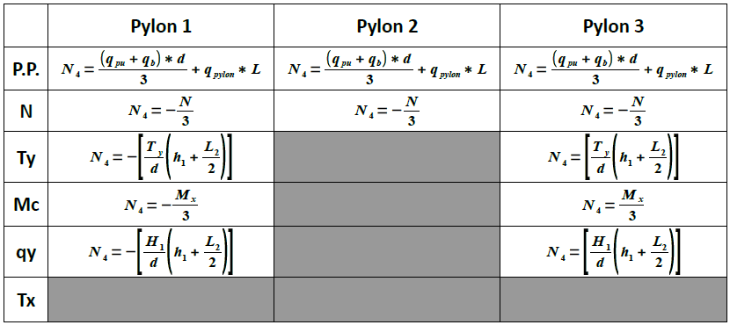

Cutting force (Tx) on Pylons is calculated by following formulas:
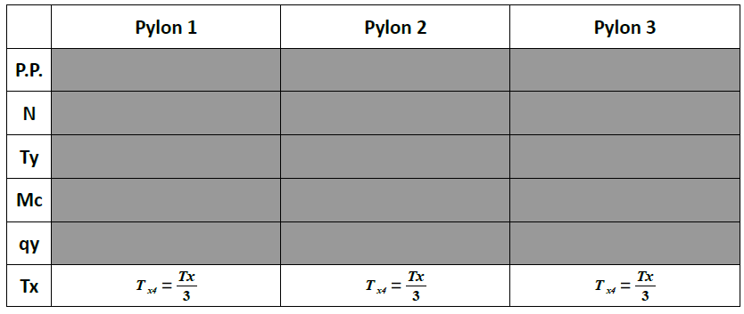
Cutting force (Ty) on Pylons is calculated by following formulas:
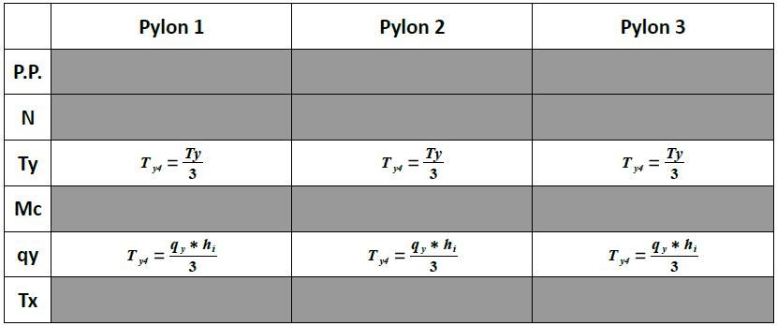
Blending stress of the bridge (Mx) is calculated for each pylon by formulas:
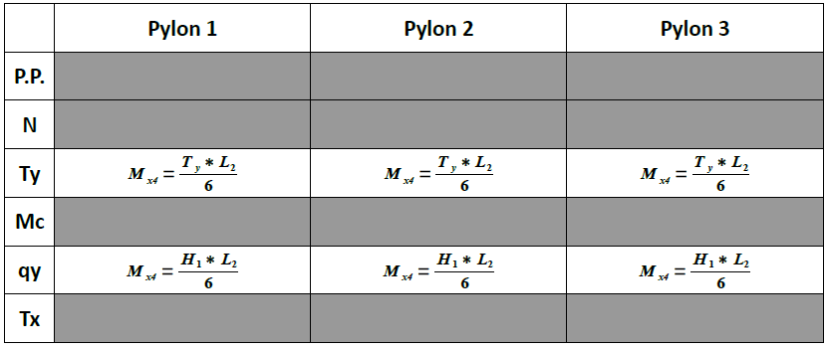

Blending stress of the bridge (My) is calculated for each pylon by formulas:
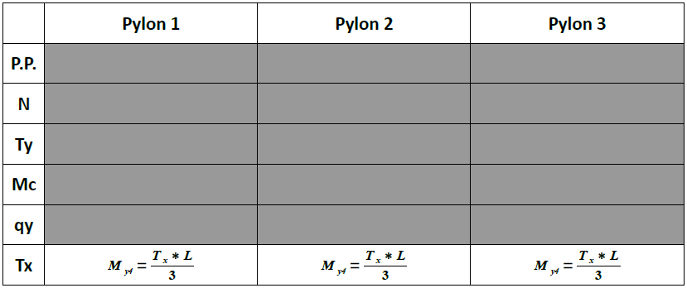

External Interfaces
The table below shows the requirements for the external interfaces of the system.
Identity  EI | Requirement Definition | Priority | Status
EI1 | The alarm button should turn red if any pylon is outside the M-N domain. | 1 | I
EI2 | A Google Earth picture of the bridge and an icon of a wind rose should be visible on each page. | 5 | I
EI3 | A link to external webpages which show the measurements of river Po should be present on each page. | 5 | I
EI4 | A film of the day, the week and month based on the pictures should be visible to the human controller. | 5 | I

Warning messages
The table below shows the requirements for the warning messages.
Identity  WM | Requirement Definition | Priority | Status
WM1 | A warning message "Are you sure you want to delete this user?" should appear if the administrator chooses to delete a registered user. | 5 | I
WM2 | A warning message "Are you sure you want to change the range of risk factors" should appear if the engineer chooses to change ranges of risk factors. | 5 | I

Non-Functional requirements
There are five types of non-functional requirements: Performance (PE), Usability (U), Extensibility (Ex) and Security (S). They are presented in the following table.
Identity | Requirement Definition | Priority | Status
PE1 | The system should parse the data from the sensors and perform calculations every one hour. | 3 | I
PE1 | The loading time for each page should be less than 20 seconds. | 4 | I
U1 | Each new user of the system should be able to learn how to operate with the system within one day of tutorial. | 4 | I
Ex1 | It should be able to add new sensors to the system in the future. | 4 | I
S1 | A log in is required to sign into the system and view internal data. | 4 | I

Requirements for the future
The requirements for the future will not be prioritized since no plan is made for their implementation yet. They represent possible extensions to the system that is being developed.
Identity  F | Requirement Definition | Priority | Status
F1 | Create an Android application of the system. | N/A | F
F2 | Have a local and remote Database. Local with 'current' data (last X years). Remote with 'historical data (older than X years ago). | N/A | F

Appendix

GEOMETRY OF THE STACK N.30
Dpylon | 1.5 | m | Diameter of the pylon
cspan | 9.5 | m | Distance between two line of pylon
hbeam | 17.5 | m | Height of the lower beam
bottom_ref | 10 | m | Height of the reference of the bottom of the river
h1 | 7.3 | m | Distance between the pulvino and the inferior beam
h2 | 7.5 | m | Distance between the inferior beam and the bottom_ref
(h1)/2 | 3.65 | m | Mean value of h1
k | 0 | m | Sinking of the bases over the ground
d | 8.5 | m | Width of the chassis
RIpylon | 0 | m | Internal radius
numb_id_bar | 12 | -- | Number of identical bars
Dbar | 0,024 | m | Bars diameter
Ccb | 0,042 | m | Barycentric concrete cover
Steel_class | FeB44K | -- | Steel class
Concrete_class | C25/30 | -- | Concrete class
WIND THRUST
α | 6 | ° | Planimetric anticlockwise inclination of the bridge form the north
CDwi | 2 | - | “Drag planking” coefficient
ρair | 1.2 | Kg/m3 | Air density
Astack | 168 | m2 | Planking area exposed to the wind pressure
Atraf | 177 | m2 | Surface of traffic exposed to the wind pressure
β1 | 1 | - | Coefficient of reduction for A1 and A2 traffic scenarios
β2 | 0.5 | - | Coefficient of reduction for A3 traffic scenario
r | 2.25 | m | Thrust center due to longitudinal asymmetry, only of SVplank
eplank | 1.91 | m | “arm” for bending moment of SVplank
etraf | 3.41 | m | “arm” for bending moment of SVtraf
HYDRODYNAMIC THRUST
CD0wa | 2.4 | - | “Drag planking” coefficient (D=0)
CD1wa | 2 | - | “Drag planking” coefficient (D=1)
ρwater | 1000 | Kg/m3 | Water density
βA | 0.5 | - | Area reduction for D=1
a | -0.0014 | - | Coefficient for the relation Vwater([IDRO1])
b | 0.0341 | - | Coefficient for the relation Vwater([IDRO1])
c | 0.052 | - | Coefficient for the relation Vwater([IDRO1])
hwater1 | 17 | m | Height limit of the river for parameters a1,b1,c1
a1 | 46 | - | Coefficient for Q(h) when [IDRO1] < hwater1
b1 | -902 | - | Coefficient for Q(h) when [IDRO1] < hwater1
c1 | 4658 | - | Coefficient for Q(h) when [IDRO1] < hwater1
hwater2 | 22 | m | Height limit of the river for parameters a2,b2,c2
a2 | 60 | - | Coefficient for Q(h) when [IDRO1] < hwater2
b2 | -1350 | - | Coefficient for Q(h) when [IDRO1] < hwater2
c2 | 8000 | - | Coefficient for Q(h) when [IDRO1] < hwater2
hmax | 25.3 | m | Max height level of river and limit for use parameter a3,b3,c3
a3 | 96 |  | Coefficient for Q(h) when hwater2 < [IDRO1] < hmax
b3 | -2800 |  | Coefficient for Q(h) when hwater2 < [IDRO1] < hmax
c3 | 22500 |  | Coefficient for Q(h) when hwater2 < [IDRO1] < hmax
WEIGHT OF THE STACK
Pp | 10710 | kN | Plank weight on the stack
Ppu | 1680 | kN | Weight of single pulvino
Ptp | 1601 | kN | Weight of the trunk of pylon
Pb | 1007 | kN | Weight of the single beam
Ppy | 44 | kN/m | Weight per meter of pylon
Mt | 9720 | kNm | Moment generated by asymmetry
MOBILE WEIGHTS
N(A1) | 4024 | kN | Axial load for load combination A1
Mxx(A1) | 4368 | kNm | Bending moment for load combination A1
Myy(A1) | 3908 | kNm | Bending moment for load combination A1
N(A2) | 3116 | kN | Axial load for load combination A2
Mxx(A2) | 8077 | kNm | Bending moment for load combination A2
Myy(A2) | 3015 | kNm | Bending moment for load combination A2
N(A3) | 1979 | kN | Axial load for load combination A3
Mxx(A3) | 2121 | kNm | Bending moment for load combination A3
Myy(A3) | 25756 | kNm | Bending moment for load combination A3
Vehicle braking
Fr | 206 | kN | Value of the force due to the vehicle braking
n | 3.3 | m | “arm” for the vehicle braking moment

